CSIT314 Software Development Methodologies - Group Project

Sprint 3 - US36: Customer log out
Interior Design Platform - Customer
Open "US36 Customer log out.drawio" to edit the diagrams and wireframes. Separate PNGs are in "diagrams". Screens follow the shared customer header, login card and message styles.

Assumptions
- US36 ends the current customer browser session and returns to customer login. Dashboard, search and project details then require a new login.
- The Log out button in customerBase.html submits POST /customer/logout from every customer page using that layout. GET and other write methods do not trigger logout.
- CustomerLogoutPage calls CustomerLogoutController, which reuses the existing US2 LogoutController. No Entity is required because no persistent records change.
- The controller clears the entire session, including identity fields, old flashes and transient action data. It also clears orphaned data when userId is already absent.
- A session containing userId produces "You have logged out successfully"; an already-ended session produces "Your session has already ended". Both redirect to /customer/login.
- The new feedback is flashed once and consumed by the customer login GET. Only this temporary message survives the logout response; no authentication data survives.
- Logout does not require an Active account/profile or a database lookup, so revoked or deleted accounts can still end their current browser session.
- Existing no-store response headers apply. Later protected requests recheck the session and redirect to login. A browser screenshot is not a substitute for this server access check.
- Scope follows the existing Flask signed-cookie session design: this browser only. It does not revoke other browsers/devices or previously copied cookies. Account, IDP and saved-project data remain unchanged.

1. User story
Story ID | US36
User story | As a customer, I want to log out so that other people cannot use my account.
Actor | Customer
Priority | To be agreed
Story points (estimate) | To be agreed
Acceptance criteria | 1. Customer pages provide a POST Log out action in the shared header.  2. Log out clears identity and transient session data and returns to customer login with a success message.  3. Repeated logout or an already-ended session shows an information message and clears orphaned data.  4. Dashboard, search and IDP details require a new login after logout.  5. Logout remains possible after account/profile/permission revocation.  6. Feedback is displayed once; responses use the existing no-store policy.  7. No persistent records change and other browser sessions are unaffected.
Tasks | T36.1 Define logout scope and session cleanup.  T36.2 Draw use case, class and combined sequence diagrams.  T36.3 Create template-matching wireframes.  T36.4 Test session cleanup, feedback and protected access.  T36.5 Reuse shared logout in the customer controller.  T36.6 Add the customer route/header action and login feedback.  T36.7 Run all tests and review the Word document.

2. Use case diagram
UC36 Customer log out has the Customer as its sole actor. Clearing session data and showing feedback are internal flows. Login is a separate use case required for later protected access.
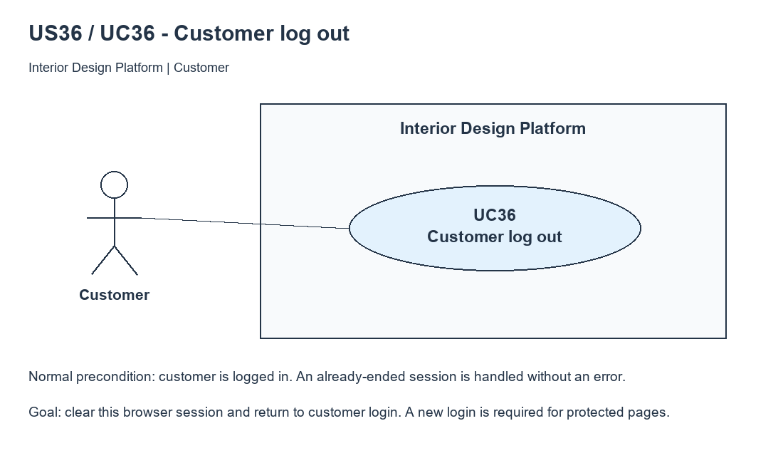
Figure 1: Use case diagram for US36 Customer log out

3. Use case description
Use case | UC36 Customer log out
Actor | Customer
Brief description | The customer ends the current browser session to prevent continued access without logging in again.
User story | US36: As a customer, I want to log out so that other people cannot use my account.
Preconditions | Normally an authenticated customer session. Empty, stale or revoked sessions are also handled. No account/profile database access is required.
Trigger | Customer selects Log out in the shared customer header.
Basic flow | 1. Customer selects Log out; the form submits POST /customer/logout.  2. Boundary calls CustomerLogoutController.logout().  3. Controller delegates to shared LogoutController, which checks userId and clears an authenticated session.  4. Customer controller always clears remaining session data, including orphaned values, and returns whether authentication was present.  5. Boundary flashes the success message and redirects to /customer/login.  6. Customer login GET shows and consumes the message.  7. A subsequent dashboard/search/detail request has no userId and redirects to customer login.
Alternative flows | 3a. No userId/already-ended session: clear any remaining data, flash "Your session has already ended" as info and redirect to customer login.  1a. GET/PUT/PATCH/DELETE: HTTP 405; the session is not ended.  2a. Access has been revoked or the account deleted: logout still clears the session without authentication/database queries.  6a. Login page is refreshed: the one-time feedback is no longer shown.  7a. Customer logs in again: access is restored only after the normal US30 checks.  7b. Another browser remains logged in; this story ends only the current browser session.
Postconditions | The current browser carries no authentication identity or transient action data. Login feedback is temporary and consumed on display. Protected routes require login; persistent records and other browsers remain unchanged.

4. Wireframes
These wireframes follow customerBase.html, customerLogin.html and static/style.css. They show the header action, successful logout, an already-ended session and a later protected request returning to login.

4a - Log out from a customer page
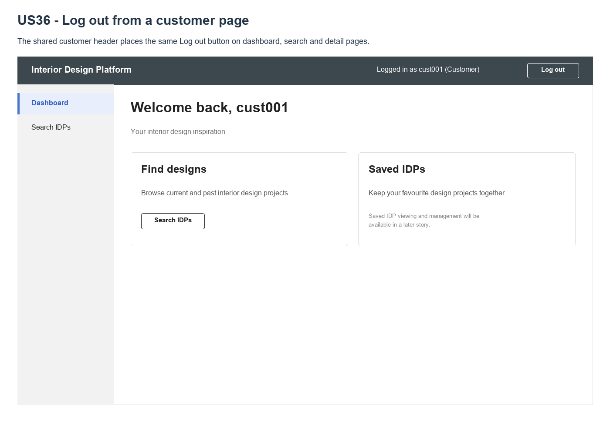
Figure 2: Wireframe 4a - Customer logout action (US36)

4b - Logout successful
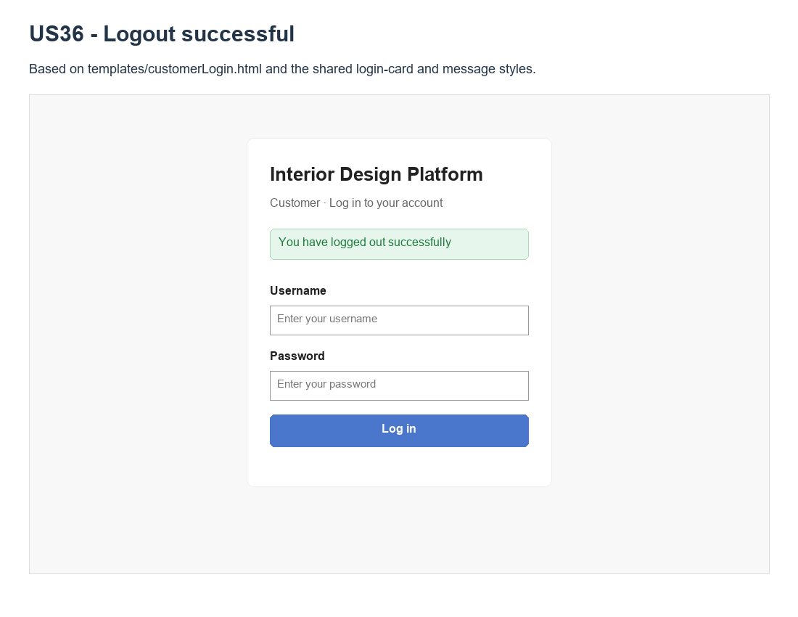
Figure 3: Wireframe 4b - Logout successful (US36)

4c - Session already ended
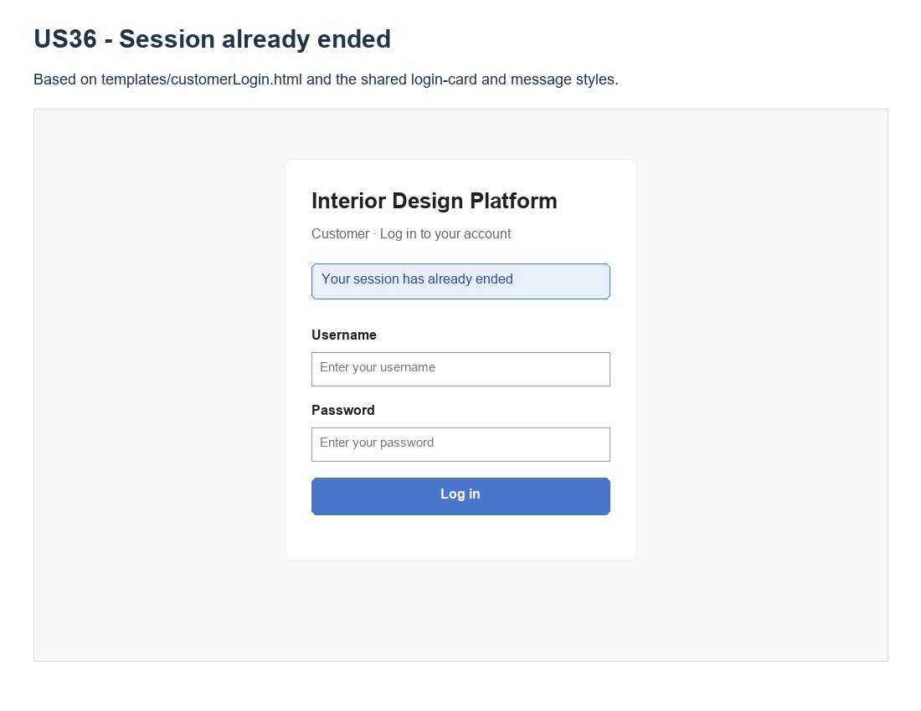
Figure 4: Wireframe 4c - Session already ended (US36)

4d - Protected page after logout
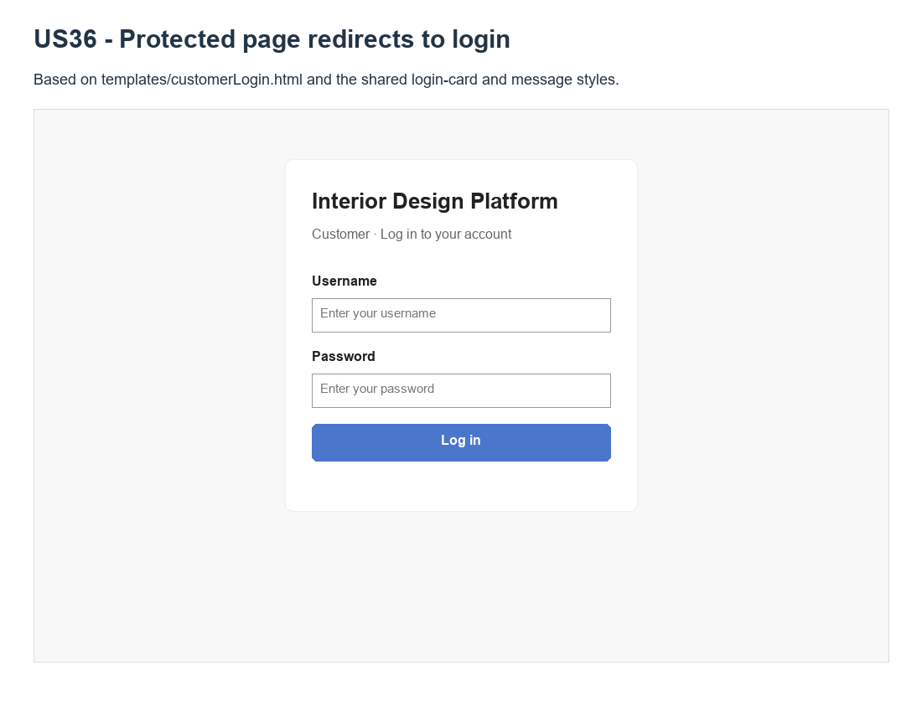
Figure 5: Wireframe 4d - Protected page redirects to login (US36)

5. B-C-E class diagram
The boundary redirects and provides one-time feedback. The customer controller reuses shared logout and always clears leftover session data. Flask session is shown as a framework dependency, not a persistent Entity.
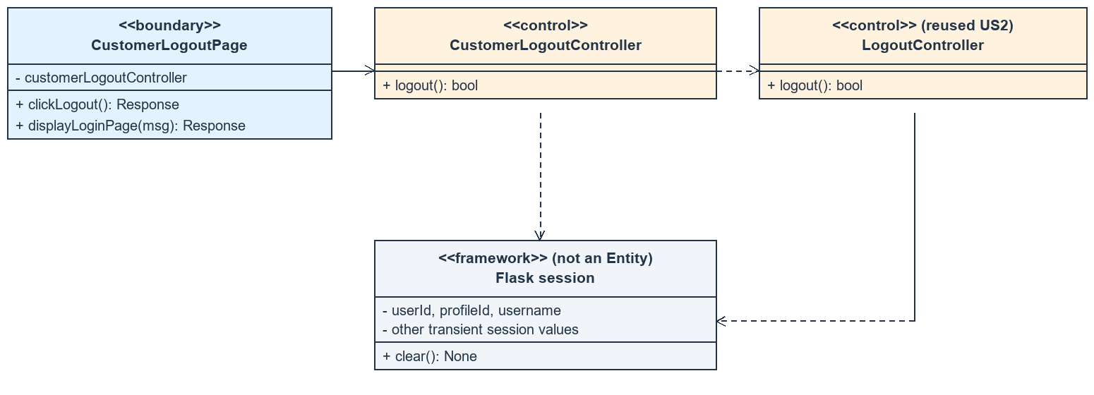
Figure 6: Boundary-Control class diagram for US36 Customer log out
Layer | Class | What it does
Boundary | CustomerLogoutPage | Delegates logout, flashes the correct message and redirects to customer login.
Control | CustomerLogoutController | Reuses shared logout and always clears remaining session values.
Reused control | LogoutController | Checks for userId, clears an authenticated session and returns a boolean.
Framework | Flask session / flash | Stores current-browser session state and one-time feedback; not a persistent Entity.

6. Sequence diagram
One combined sequence covers logout delegation, session clearing, success/already-ended alternatives, login feedback and subsequent protected access.
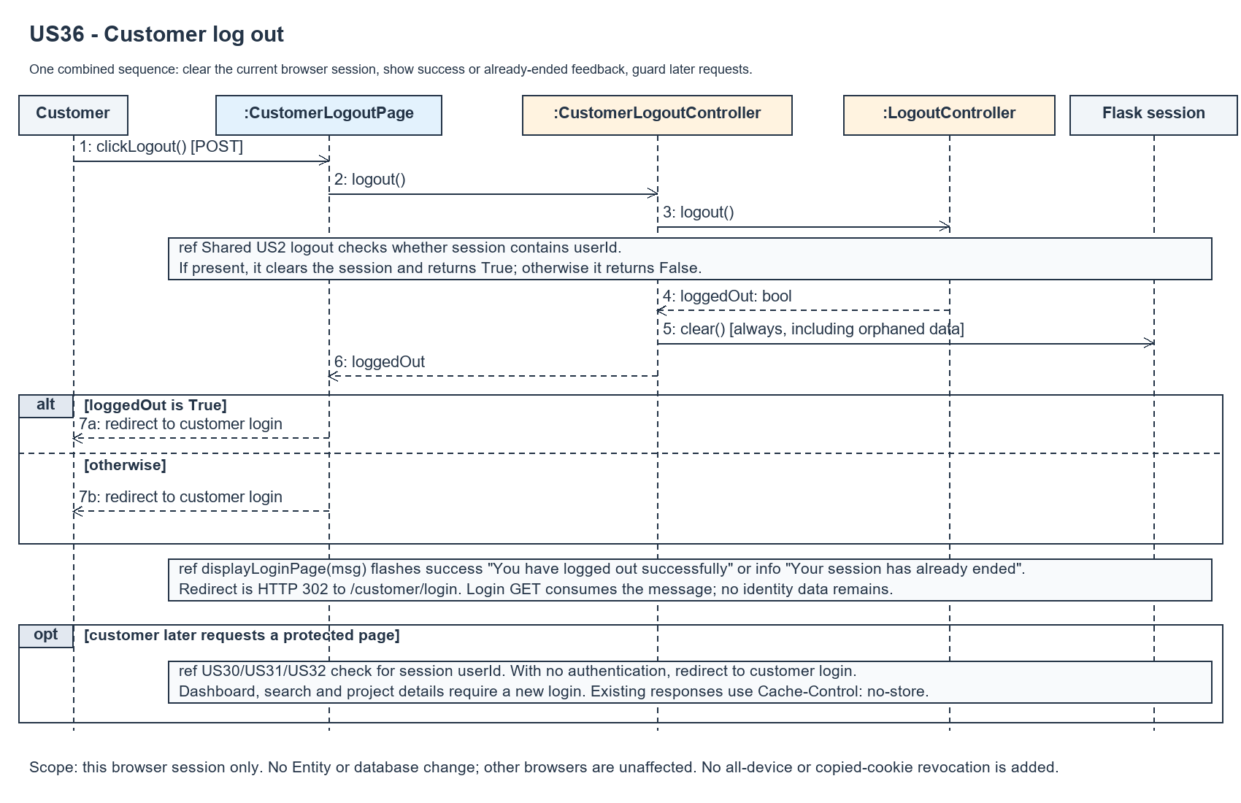
Figure 7: Combined sequence diagram for UC36 Customer log out

7. Test cases
Fixtures: an authenticated Customer, visible/hidden IDPs and a company profile. Variants include an empty/orphaned session, revoked access and another browser. Tests use isolated databases.

7a. System test cases (black box)
System scenarios cover header actions, feedback, repeat logout, session cleanup, protected routes, access revocation and unchanged records. Manual outcome cells remain blank.
Test ID | Scenario | Prerequisites | Test steps | Test data | Expected result | Actual result | Pass / Fail
TC36.1 | Header action | Customer logged in. | Check each customer page. | Dashboard/search/details | POST customer logout button shown.
TC36.2 | Successful logout | Active session. | Select Log out. | Customer session | Login page; success message.
TC36.3 | Identity cleanup | Session has identity/action data. | Log out; inspect session. | Identity + transient fields | No authentication/action values remain.
TC36.4 | Already ended | No authentication session. | Submit logout. | No userId | Info message; no error.
TC36.5 | Orphaned data | Anonymous session has leftovers. | Submit logout. | Old username/token | Leftovers cleared; info message.
TC36.6 | Protected access | Customer logged out. | Open protected pages again. | Dashboard/search/details | Redirect to customer login.
TC36.7 | Revoked access | Account/profile access revoked. | Submit logout. | Suspended/deleted account | Logout still completes.
TC36.8 | Feedback once | Logout completed. | Refresh login page. | Consumed message | No repeat feedback.
TC36.9 | Unsupported method | Customer logged in. | Request logout with other methods. | GET/PUT/PATCH/DELETE | 405; session remains active.
TC36.10 | Login again | Logout completed. | Submit valid credentials. | cust001 / Cust@123 | Normal US30 login succeeds.
TC36.11 | Other browser | Two logged-in browsers. | Log out in first browser. | Same account | First blocked; second unaffected.
TC36.12 | Read only / cache | Customer logged in. | Compare DB and response headers. | Logout + protected request | No record changes; no-store headers.

7b. Unit test cases (for TDD)
These 30 numbered cases map to tests/test_us36_customerLogout.py and expand to 38 automated checks. Controller means CustomerLogoutController; Boundary means CustomerLogoutPage. Unit outcomes reflect the verified run; manual outcomes remain blank.
Test ID | Class and method | Input / setup | Expected output | Type | Pass / Fail
UT36.1 | Controller.logout() | Session has identity. | True; session empty. | Normal | Pass
UT36.2 | Controller.logout() | No session. | False; no error. | Abnormal | Pass
UT36.3 | Controller.logout() | Call twice. | True then False. | Boundary | Pass
UT36.4 | Controller.logout() | Identity, old flashes and transient data. | All existing values cleared. | Normal | Pass
UT36.5 | Controller.logout() | Orphaned username/profile/token. | False; leftovers cleared. | Abnormal | Pass
UT36.6 | Controller.logout() | Shared logout stubbed. | Delegated once; wrapper still clears. | Normal | Pass
UT36.7 | Boundary.clickLogout() | Controller stubbed. | Delegates; 302 response. | Normal | Pass
UT36.8 | Dashboard header | Authenticated customer. | POST /customer/logout button. | Normal | Pass
UT36.9 | Search header | Authenticated customer. | Customer logout action shown. | Normal | Pass
UT36.10 | Detail header | Visible project. | Customer logout action shown. | Normal | Pass
UT36.11 | Unavailable detail header | Missing IDP. | 404 still has logout action. | Normal | Pass
UT36.12 | Logout POST | Authenticated customer. | 302 to /customer/login. | Normal | Pass
UT36.13 | Logout + login GET | Authenticated session. | Success status message; login form. | Normal | Pass
UT36.14 | Logout response session | Identity + stale values/flash. | Only new one-time feedback remains. | Normal | Pass
UT36.15 | Anonymous logout | No userId. | Info message; HTTP 200 after redirect. | Abnormal | Pass
UT36.16 | Repeated logout | Logout twice. | Second reports already ended. | Boundary | Pass
UT36.17 | Other HTTP methods | GET/PUT/PATCH/DELETE. | 405; customer remains authenticated. | Abnormal | Pass
UT36.18 | Protected routes after logout | Dashboard/search/detail. | Redirect to customer login. | Normal | Pass
UT36.19 | Logout after revocation | Account/profile/permission/deletion. | Success; no identity remains. | Abnormal | Pass
UT36.20 | Relogin | Logout then valid login. | Dashboard/detail accessible again. | Normal | Pass
UT36.21 | Two browsers | Same customer in both. | Only current browser logged out. | Normal | Pass
UT36.22 | Database snapshot | Before/after logout. | No persistent changes; account valid. | Normal | Pass
UT36.23 | Response cache policy | Logout/login/protected redirect. | Cache-Control: no-store. | Normal | Pass
UT36.24 | Existing admin logout | Admin uses /logout. | Existing behaviour preserved. | Normal | Pass
UT36.25 | Existing designer logout | Designer uses /designer/logout. | Designer login redirect preserved. | Normal | Pass
UT36.26 | One-time feedback | Logout then refresh login. | Message shown only once. | Normal | Pass
UT36.27 | Submitted query/form data | Forged identity and external URL. | Cleared; fixed customer login redirect. | Abnormal | Pass
UT36.28 | No entity dependency | Account/profile reads forbidden. | Logout still completes. | Abnormal | Pass
UT36.29 | Session cookie | Logout followed to login. | Cookie expired after message consumed. | Normal | Pass
UT36.30 | Orphaned browser session | No userId; other saved fields. | Info message; session empty. | Abnormal | Pass

